**3.Pysical Model**

**Type of indexes in the physical design model**

**1-primary key index: Each dimension must have a pk**

**2-Foreign key index: Each fact table has foreign keys that connect to its dimensions**

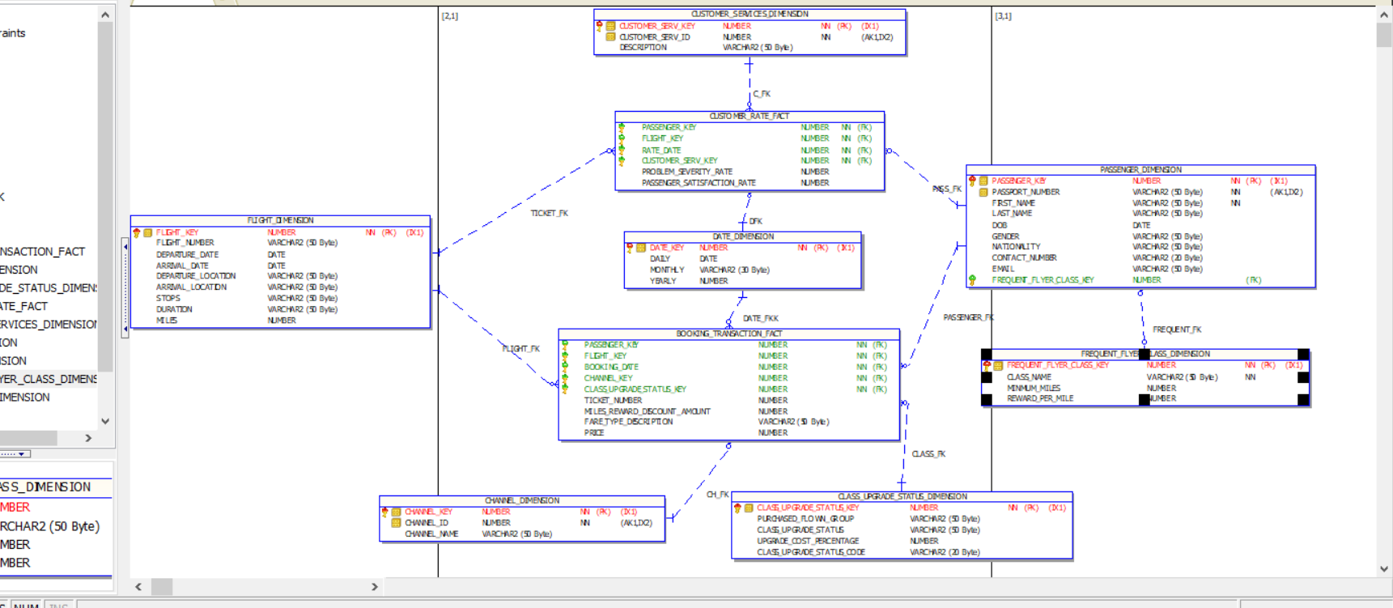

**4.DDLS**

**PASSENGER_DIMENSION**

CREATE TABLE PASSENGER_DIMENSION

(

PASSENGER_KEY NUMBER,

PASSPORT_NUMBER VARCHAR2(50 BYTE) NOT NULL,

FIRST_NAME VARCHAR2(50 BYTE) NOT NULL,

LAST_NAME VARCHAR2(50 BYTE),

DOB DATE,

GENDER VARCHAR2(50 BYTE),

NATIONALITY VARCHAR2(50 BYTE),

CONTACT_NUMBER VARCHAR2(20 BYTE),

EMAIL VARCHAR2(50 BYTE),

FREQUENT_FLYER_CLASS_KEY NUMBER

)

ALTER TABLE PASSENGER_DIMENSION ADD (

CONSTRAINT PASSENGER_DIMENSION_PK

PRIMARY KEY (PASSENGER_KEY)

);

ALTER TABLE PASSENGER_DIMENSION ADD (

CONSTRAINT FREQUENT_FK

FOREIGN KEY (FREQUENT_FLYER_CLASS_KEY)

REFERENCES HR.FREQUENT_FLYER_CLASS_DIMENSION (FREQUENT_FLYER_CLASS_KEY));

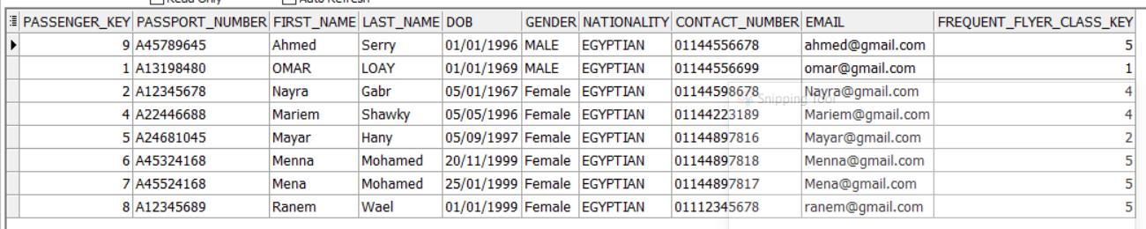

**FREQUENT_FLYER_CLASS_DIMENSION**

CREATE TABLE FREQUENT_FLYER_CLASS_DIMENSION

(

FREQUENT_FLYER_CLASS_KEY NUMBER,

CLASS_NAME VARCHAR2(50 BYTE) NOT NULL,

MINMUM_MILES NUMBER,

REWARD_PER_MILE NUMBER

)

ALTER TABLE FREQUENT_FLYER_CLASS_DIMENSION ADD (

CONSTRAINT FREQUENT_FLYER_CLASS_DIMENS_PK

PRIMARY KE (FREQUENT_FLYER_CLASS_KEY) );

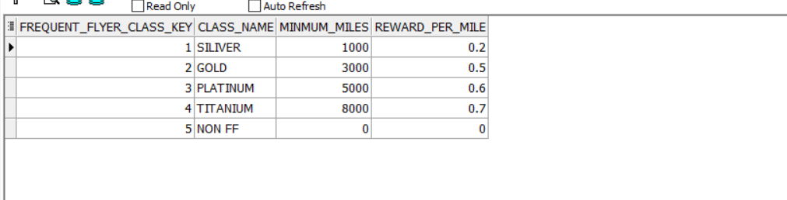

**FLIGHT_DIMENSION**

CREATE TABLE FLIGHT_DIMENSION

(

FLIGHT_KEY NUMBER,

FLIGHT_NUMBER VARCHAR2(50 BYTE),

DEPARTURE_DATE DATE,

ARRIVAL_DATE DATE,

DEPARTURE_LOCATION VARCHAR2(50 BYTE),

ARRIVAL_LOCATION VARCHAR2(50 BYTE),

STOPS VARCHAR2(50 BYTE),

DURATION VARCHAR2(50 BYTE),

MILES NUMBER

)

ALTER TABLE FLIGHT_DIMENSION ADD (

CONSTRAINT TICKET_DIMENSION_PK

PRIMARY KEY

(FLIGHT_KEY)

);

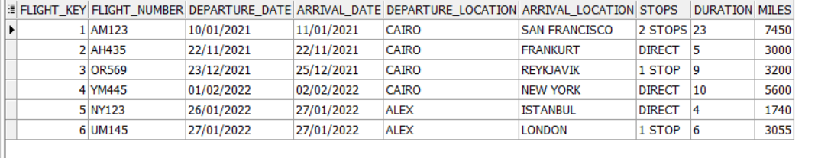

**CUSTOMER_SERVICES_DIMENSION**

CREATE TABLE CUSTOMER_SERVICES_DIMENSION

(

CUSTOMER_SERV_KEY NUMBER,

CUSTOMER_SERV_ID NUMBER NOT NULL,

DESCRIPTION VARCHAR2(50 BYTE)

)

ALTER TABLE CUSTOMER_SERVICES_DIMENSION ADD (

CONSTRAINT CUSTOMER_SERVICES_PK

PRIMARY KEY (CUSTOMER_SERV_KEY)

CONSTRAINT CUS_SERV_UN

UNIQUE (CUSTOMER_SERV_ID)

);

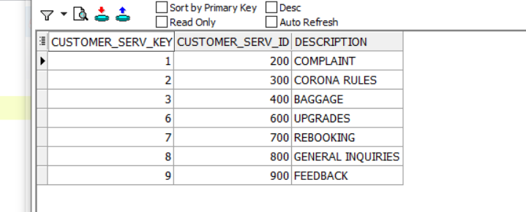

**CHANNEL_DIMENSION**

CREATE TABLE CHANNEL_DIMENSION

(

CHANNEL_KEY NUMBER,

CHANNEL_ID NUMBER NOT NULL,

CHANNEL_NAME VARCHAR2(50 BYTE)

)

ALTER TABLE CHANNEL_DIMENSION ADD (

CONSTRAINT CHANNEL_DIMENSION_PK

PRIMARY KEY

(CHANNEL_KEY)

CONSTRAINT CHANNEL_UN

UNIQUE (CHANNEL_ID) );

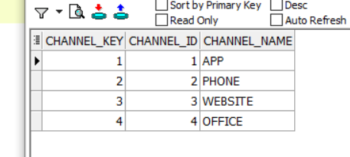

**CLASS_UPGRADE_STATUS_DIMENSION**

CREATE TABLE CLASS_UPGRADE_STATUS_DIMENSION

(

CLASS_UPGRADE_STATUS_KEY NUMBER,

PURCHASED_FLOWN_GROUP VARCHAR2(50 BYTE),

CLASS_UPGRADE_STATUS VARCHAR2(50 BYTE),

UPGRADE_COST_PERCENTAGE NUMBER,

CLASS_UPGRADE_STATUS_CODE VARCHAR2(20 BYTE)

)

ALTER TABLE CLASS_UPGRADE_STATUS_DIMENSION ADD (

CONSTRAINT CLASS_UPDATE_DIMENSION_PK

PRIMARY KEY

(CLASS_UPGRADE_STATUS_KEY));

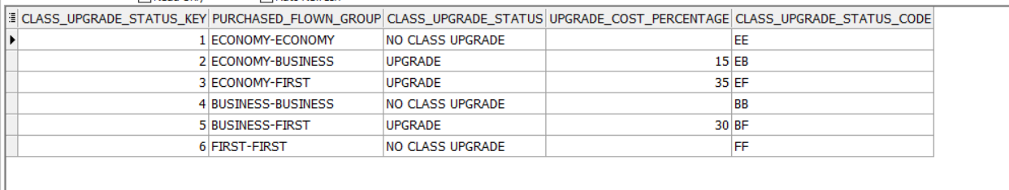

**DATE_DIMENSION**

CREATE TABLE DATE_DIMENSION

(

DATE_KEY NUMBER,

DAILY DATE,

MONTHLY VARCHAR2(30 BYTE),

YEARLY NUMBER

)

ALTER TABLE DATE_DIMENSION ADD (

CONSTRAINT DATE_DIMENSION_PK

PRIMARY KEY(DATE_KEY));

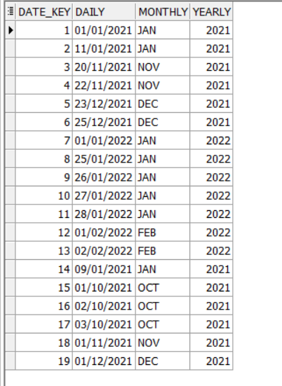

**CUSTOMER_RATE_FACT**

CREATE TABLE CUSTOMER_RATE_FACT

(

PASSENGER_KEY NUMBER NOT NULL,

FLIGHT_KEY NUMBER NOT NULL,

RATE_DATE NUMBER NOT NULL,

CUSTOMER_SERV_KEY NUMBER NOT NULL,

PROBLEM_SEVERITY_RATE NUMBER,

PASSENGER_SATISFACTION_RATE NUMBER

)

ALTER TABLE CUSTOMER_RATE_FACT ADD (

CONSTRAINT C_FK

FOREIGN KEY (CUSTOMER_SERV_KEY)

REFERENCES CUSTOMER_SERVICES_DIMENSION (CUSTOMER_SERV_KEY),

CONSTRAINT DFK

FOREIGN KEY (RATE_DATE)

REFERENCES DATE_DIMENSION (DATE_KEY),

CONSTRAINT PASS_FK

FOREIGN KEY (PASSENGER_KEY)

REFERENCES PASSENGER_DIMENSION (PASSENGER_KEY),

CONSTRAINT TICKET_FK

FOREIGN KEY (FLIGHT_KEY)

REFERENCES FLIGHT_DIMENSION (FLIGHT_KEY));

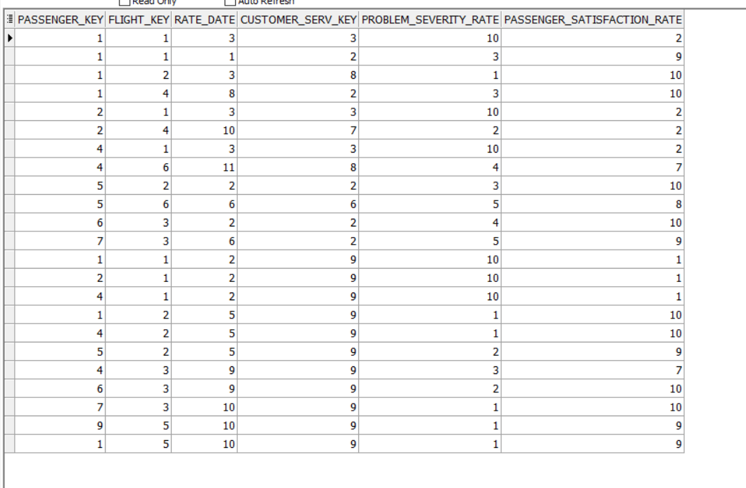

**BOOKING_TRANSACTION_FACT**

CREATE TABLE BOOKING_TRANSACTION_FACT

(

PASSENGER_KEY NUMBER NOT NULL,

FLIGHT_KEY NUMBER NOT NULL,

BOOKING_DATE NUMBER NOT NULL,

CHANNEL_KEY NUMBER NOT NULL,

CLASS_UPGRADE_STATUS_KEY NUMBER NOT NULL,

TICKET_NUMBER NUMBER,

MILES_REWARD_DISCOUNT_AMOUNT NUMBER,

FARE_TYPE_DESCRIPTION VARCHAR2(50 BYTE),

PRICE NUMBER

)

ALTER TABLE BOOKING_TRANSACTION_FACT ADD (

CONSTRAINT CH_FK

FOREIGN KEY (CHANNEL_KEY)

REFERENCES CHANNEL_DIMENSION (CHANNEL_KEY),

CONSTRAINT CLASS_FK

FOREIGN KEY (CLASS_UPGRADE_STATUS_KEY)

REFERENCES CLASS_UPGRADE_STATUS_DIMENSION (CLASS_UPGRADE_STATUS_KEY),

CONSTRAINT DATE_FKK

FOREIGN KEY (BOOKING_DATE)

REFERENCES DATE_DIMENSION (DATE_KEY),

CONSTRAINT FLIGHT_FK

FOREIGN KEY (FLIGHT_KEY)

REFERENCES FLIGHT_DIMENSION (FLIGHT_KEY),

CONSTRAINT PASSENGER_FK

FOREIGN KEY (PASSENGER_KEY)

REFERENCES PASSENGER_DIMENSION (PASSENGER_KEY));

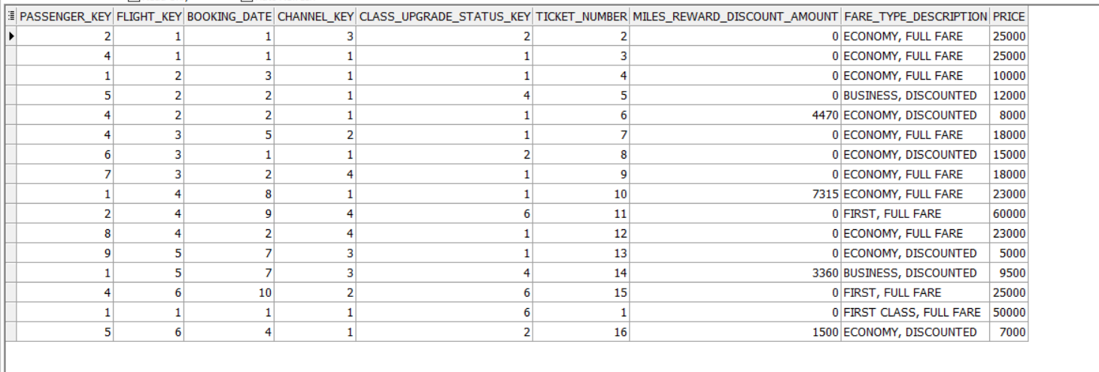

**5. SQL Queries**

**1-What FARE TYPES the company’s frequent flyers book?**

SELECT F.CLASS_NAME,FARE_TYPE_DESCRIPTION,COUNT( FARE_TYPE_DESCRIPTION ) AS NUMBER_OF_BOOKING

FROM BOOKING_TRANSACTION_FACT B

JOIN PASSENGER_DIMENSION P

ON P.PASSENGER_KEY =B.PASSENGER_KEY

JOIN FREQUENT_FLYER_CLASS_DIMENSION F

ON F.FREQUENT_FLYER_CLASS_KEY= P.FREQUENT_FLYER_CLASS_KEY

WHERE F.CLASS_NAME <> 'NON FF'

GROUP BY F.CLASS_NAME ,FARE_TYPE_DESCRIPTION

ORDER BY 3 DESC;

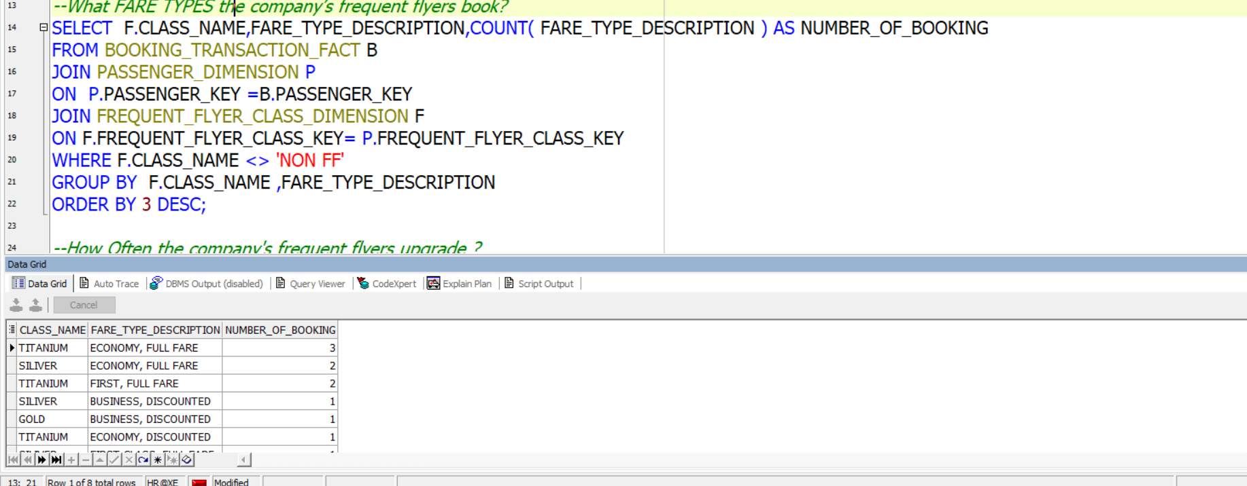

**2- ORDER channels that make most of the reservation processes ?**

SELECT COUNT(B.PASSENGER_KEY) AS TOTAL_BOOKING ,C.CHANNEL_NAME

FROM

BOOKING_TRANSACTION_FACT B , CHANNEL_DIMENSION C

WHERE B.CHANNEL_KEY=C.CHANNEL_KEY

GROUP BY C.CHANNEL_NAME

ORDER BY TOTAL_BOOKING DESC ;

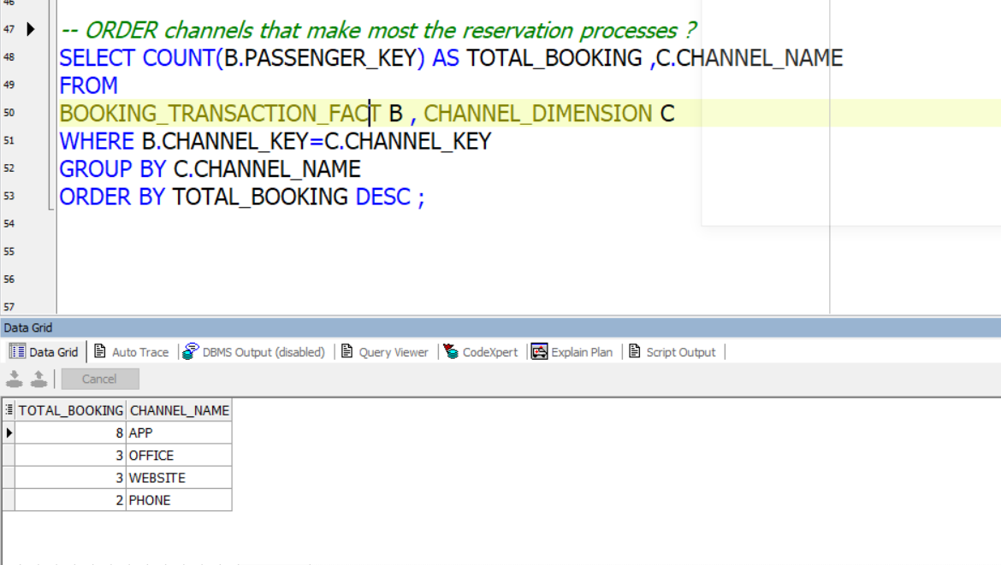

**3-List flights that have the worst Customer Rate ?**

SELECT COUNT(C.PASSENGER_SATISFACTION_RATE) AS NUMBER_OF_NEGATIVE_RATE ,F.FLIGHT_NUMBER

FROM

CUSTOMER_RATE_FACT C

JOIN FLIGHT_DIMENSION F

ON

C.FLIGHT_KEY=F.FLIGHT_KEY

WHERE C.PASSENGER_SATISFACTION_RATE <= 3

GROUP BY F.FLIGHT_NUMBER

ORDER BY NUMBER_OF_NEGATIVE_RATE DESC;

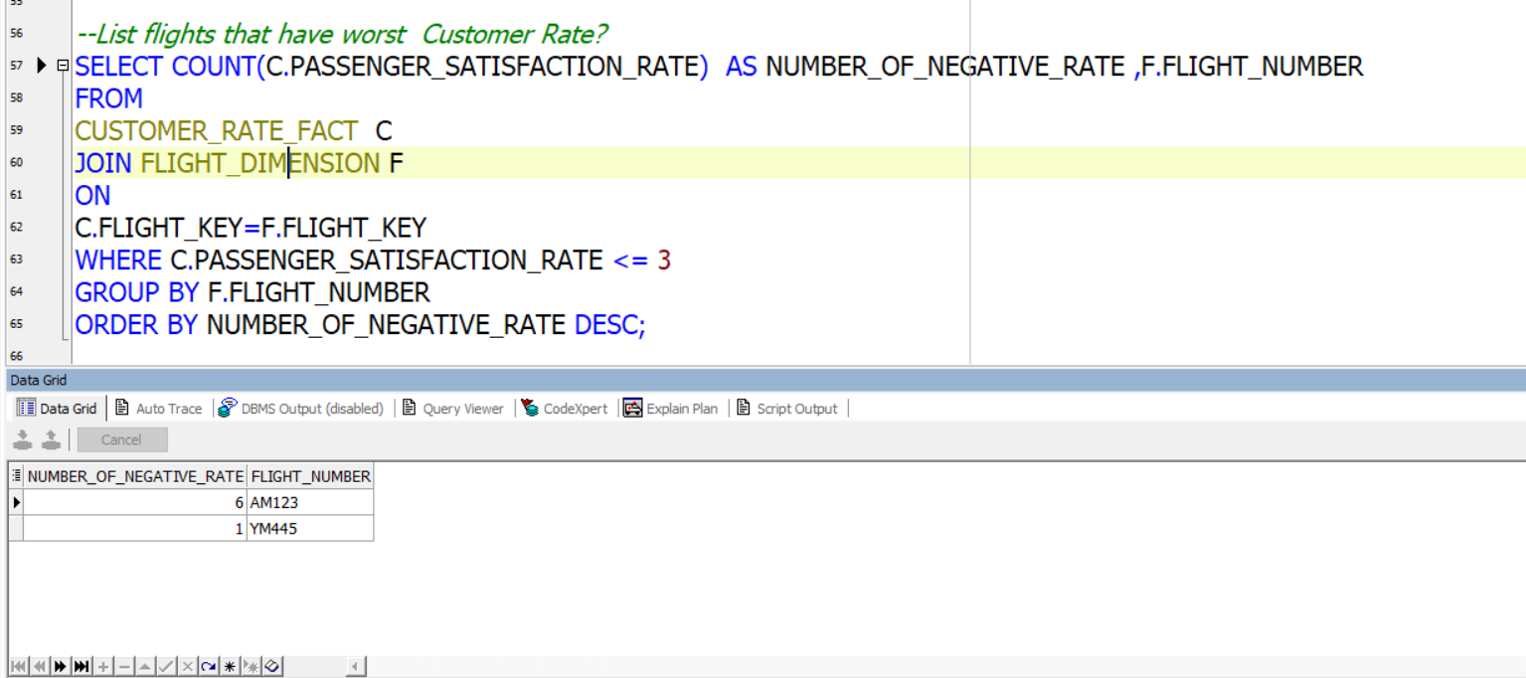

**4-List Flights that have best feedback?**

SELECT COUNT(C.PASSENGER_SATISFACTION_RATE) AS NUMBER_OF_POSITIVE_FEEDBACKS ,F.FLIGHT_NUMBER

FROM

CUSTOMER_RATE_FACT C

JOIN FLIGHT_DIMENSION F

ON

C.FLIGHT_KEY=F.FLIGHT_KEY

JOIN CUSTOMER_SERVICES_DIMENSION S

ON

S.CUSTOMER_SERV_KEY=C.CUSTOMER_SERV_KEY

WHERE C.PASSENGER_SATISFACTION_RATE >= 7 AND S.DESCRIPTION ='FEEDBACK'

GROUP BY F.FLIGHT_NUMBER

ORDER BY NUMBER_OF_POSITIVE_FEEDBACKS DESC;

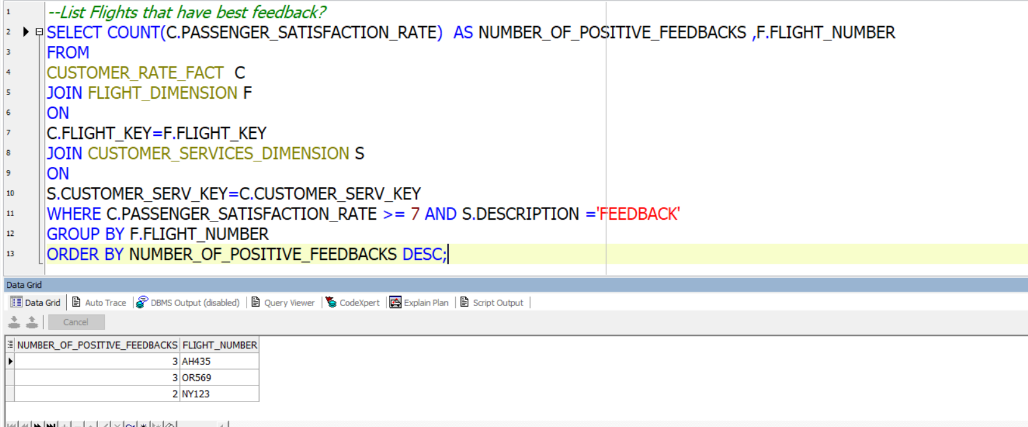

**5-List Top Loyal Frequent Flyers ?**

SELECT COUNT(B.PASSENGER_KEY) AS NUMBER_OF_FLIGHTS,P.FIRST_NAME , P.LAST_NAME , P.PASSPORT_NUMBER ,F.CLASS_NAME

FROM PASSENGER_DIMENSION P

JOIN FREQUENT_FLYER_CLASS_DIMENSION F

ON

P.FREQUENT_FLYER_CLASS_KEY=F.FREQUENT_FLYER_CLASS_KEY

JOIN BOOKING_TRANSACTION_FACT B

ON

P.PASSENGER_KEY=B.PASSENGER_KEY

WHERE F.CLASS_NAME <> 'NON FF'

GROUP BY P.FIRST_NAME , P.LAST_NAME , P.PASSPORT_NUMBER ,F.CLASS_NAME

ORDER BY NUMBER_OF_FLIGHTS DESC;

